**Table of Content**

1. Introduction of LinkedIn
2. Passed Heuristics
3. Violated Heuristics
4. References

**1.Intorduction**

LinkedIn is a professional networking site where users can make connections with peers, coworkers, and business leaders. Usability heuristics will be used as the basis for my analysis as I determine the usability of the LinkedIn mobile app in this evaluation. The evaluation will focus on how well the App follows to usability heuristics and will focus on identifying usability issues.

**2. Passed Heuristics:**

***1. User Control and Freedom:***

Users should be able to navigate and use the app with ease, including the ability to undo actions.

Here, I can be able to “Withdraw” connection request after sent it, giving control over their actions.



***2. Recognition over recall:***

The app suggests relevant hashtags and users to mention when you're writing a post based on the content you upload.

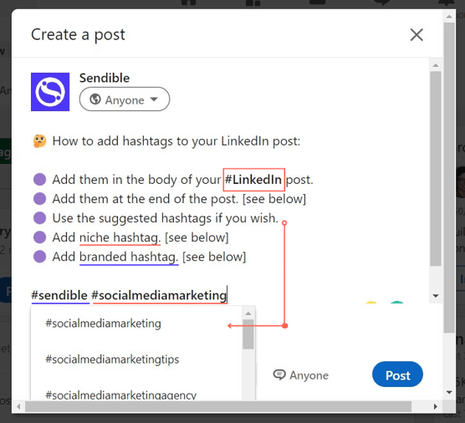



Here, I can easily accessible hashtags and connections while writing the post.

***3. Error prevention:***

The app helps to prevent errors by providing clear prompts and confirmation messages before proceeding.



Here, I can see confirmation message is asking you to confirm that you want to proceed further,

***4. Visibility of System Status:***

The app should keep users updated by providing appropriate feedback in a timely manner.

Here, progress bar indicates the state of your profile.



***5. Help Users Recognize, Diagnose, and Recover from Errors:***

When an error occurs, such as failed connection request, it helps users understand what went wrong and how to fix it. This helps users recover from errors more easily and with less frustration.



Here, message is notified to user to check internet connection and try again.

**3. Violated Heuristics:**

1. ***Consistency and Standards:***

Users may become confused by LinkedIn's inconsistent design components and navigation across different App section.

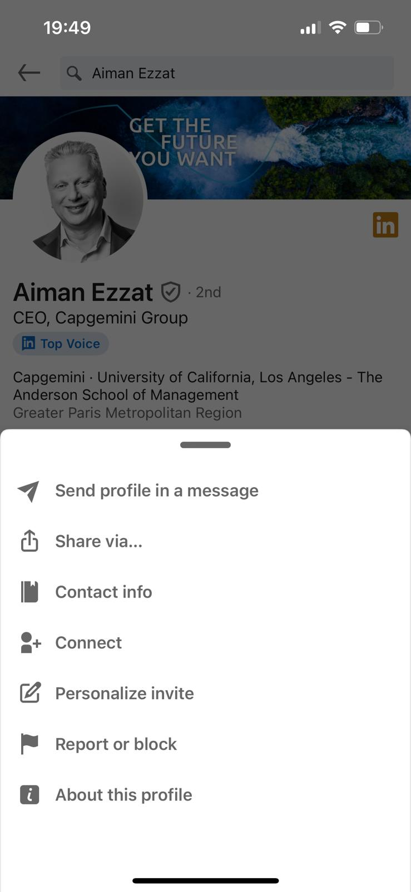



Here, rather than having a simple connect button on user’s profile, I face the difficulties to find the “Connect” button.

***2. Flexibility and Efficiency of Use:***

Users may find it difficult to quickly locate relevant possibilities under “Recommended for You” section because LinkedIn's app does not include filtering options for job searches or content discovery.

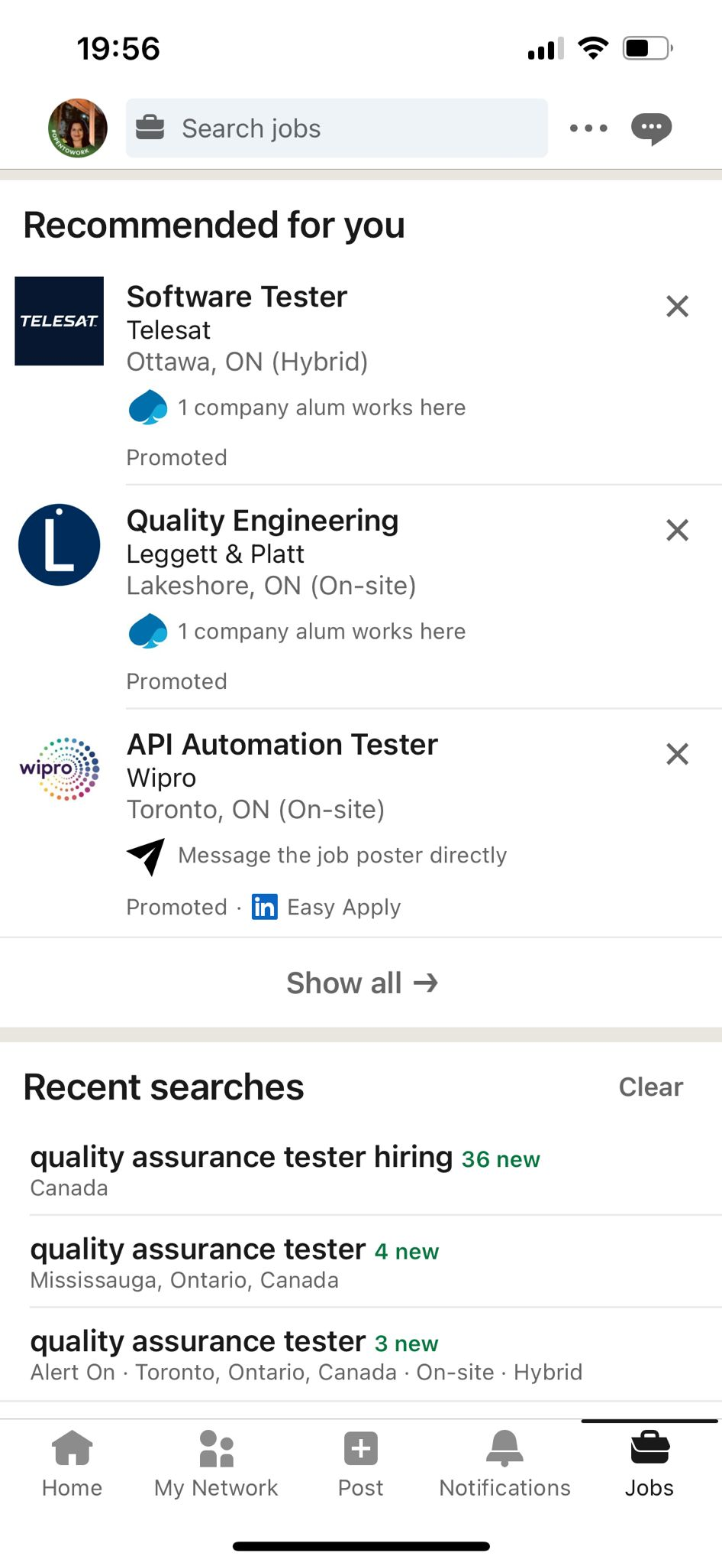



Here, it is very difficult for user to locate a particular type of jobs because LinkedIn does not provide ‘Filter’ option.

***3. Aesthetic and Minimalist Design***

Although LinkedIn has a fairly simple design, the interface can feel cluttered with buttons, features, and advertising, which takes away from the clean look.



Here, I can see all the cluttered posts with promotional ads within.

***4.Help Users Recognize, Diagnose, and Recover from Errors:***

When messages are unsuccessful because of internet connectivity problems, LinkedIn's error messages can occasionally be ambiguous or useless.



Here, we cannot the further action needed for a user to send the text message or retry sending it.

**4. References:**

1. Nielsen, J., & Molich, R. (1990). Heuristic evaluation of user interfaces. In Proceedings of the SIGCHI conference on Human factors in computing systems (pp. 249-256).
2. Nielsen, J. (1995, January 1). 10 usability heuristics for user interface design